# **SOLUTION ARCHITECTURE**

# **PEROSONAL EXPENSE PERSONAL APPLICATION**

# **abstract:**

# Mobile applications are top in user convenience and have overpassed the web applications in terms of popularity and usability. There are variousmobile applications that provide solutions to manage personal and group expense but not many of them provide a comprehensive view of both cases. In this paper, we develop a mobile application developed for the android platform that keeps record of user personal expenses, his/her contribution in group expenditures, top investment options, view of the current stock market, read authenticated financial news and grab the best ongoing offers in the market in popular categories. The proposed application would eliminate messy sticky notes, spreadsheets confusion and data handling inconsistency problems while offering the best overview of your expenses. With our application can manage their expenses and decide on their budget more effectively.

**Keywords:** Android platform, Personal expenses, Group Expenses, Investment, Stock Market, Split Bills

## 1. Introduction

The Expense Manager is a multi-purpose finance related android application intended to run on android devices. The android application can be run on all android devices above android version 5.0. It is designed efficiently to give you the best suggestions for finance planning. The application size is less than 10 MB. It doesn’t need any high end hardware specification. It can easily run on low end devices. The features of the app are designed in a way to help you for better finance management planning so that you can keep track of , analyse and optimize your budget or spending’s. In this application we are also going to collect user’s data with authenticated permissions and analyse and study their pattern expenses in certain category or by distinct kinds of spending that can be used for studying market trends. These analysis patterns can be derived using some data mining techniques such as clustering, classification and association.

In this world of growing technologies everything is digitalized. With large number of money transaction it is difficult for user to keep track of all your transaction. The main aim of this paper is to manage personal and group expenses. Not many applications provide a variety of features within a single application.We develop an android application that keeps record of user personal expenses,

Content from this work may be used under the terms of theCreativeCommonsAttribution 3.0 licence. Any further distribution of this work must maintain attribution to the author(s) and the title of the work, journal citation and DOI.

Published under licence by IOP Publishing Ltd

his/her personal contribution towards group expenses, top investment options , view stock market , read authenticated news and grab the best ongoing offers in the market in popular categories.

## 2. Background Study

The idea of developing this paper in platform arises with the lack of financial awareness in the country as well as frequent concerns being experienced by people to manage their money properly. Some of the problem include selecting the right investment option suitable for them, reading authenticated financial news, splitting bill among friends and groups, having a good stock market analysis interface and being aware of the latest ongoing promotions at various ecommerce websites. Some of traditional methods used to tackle this problems in daily life is the use of sticky notes. Proficient people deal with problems by using spreadsheet to record expenses, this is easy when the data is small but when the data is large it becomes unmanageable.

There exists problems in certain areas like there no proper data consistency, some critical inputs may be missed and manual errors may occur. The data recorders and handlers have a hectic experience in managing the large chunks of data so, we believe that a mobile application with a good user interface can easily handle these problems as it can give comprehensive view and the app is intelligent enough to suggest the best options as per the budget selected by the user.

## 3. Objective Of Research

The android applications present in the app store are very helpful to the smartphone users and make their life easy. The expense manager android application is one among those applications, which provides a variety of help in daily life. As there are many similar applications available trying to solve the same problem but are not effective, today we added some innovative features to make our application unique, easy to use and efficient, this is what makes our application standout from the rest of others. Other than adding unique features like integrating group expenses and personal expenses into one single application, we also added features like trends andestimations. We have developed this idea after numerous surveys from friends and family. This idea serves as main objective of this research paper. The research also includes syncing of applications with personal email IDs or social network account which help also help us to serve better recommendations and personalised marketing campaigns.

**4. Features Of Application**

* Keep track of all your daily transactions.
* Keep track of your money lent or borrowed.
* Suggest you with the best investment options.
* Offers in popular categories.
* To view stock market.
* To read latest authenticated financial news.

## 5. Methodology

This section of paper we discuss how the paper is going to be developed and deployed, we are going to discuss the tools and technologies required in successful completion of this paper. We have designed architecture diagrams and layouts which we are going to use in our user interface which is user friendly i.e. easy to understand and use .We have a clear objective to make the application efficient that can run even on low end devices. Each method that we follow are the best practices as per industry standards. Below are the list of all programming languages, tools and technologies used in this paper

* Android studio
* Kotlin and Java
* SQLite
* Android OS
* Figma Designing tool

Next we discuss the architecture / workflow of each feature present in the application:

### 5.1. Expense Tracker

This is the first phase after installing the application. We need to give SMS read permission to the app since the whole idea of the app revolves around the transactions made online for which you get a message after any transaction done.

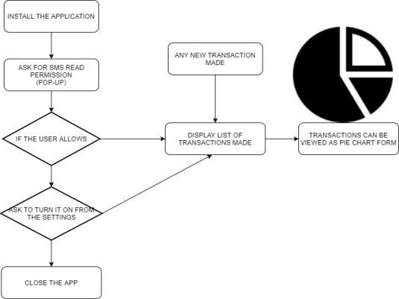

Fig 1: Expense Tracker Architecture

### 5.2. Investment Consustant

This is the second feature of the app. It asks for the user’s budget for investment. Accordingly the app suggest the best suitable option using the help of the algorithm designed.

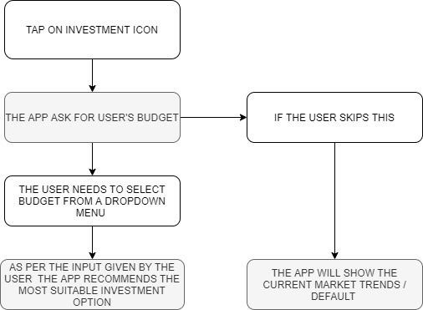

Fig 2: Investment Consultant Architecture

### 5.3. Splitbill

This feature is used to split bills among friends and groups i.e. any record of money lent or borrowed is stored here. The user needs to tap on add menu and then the user needs to enter the name and amount. The user needs to add +Rs.if money is lent and -Rs. if money is borrowed .Each transaction is stored in the database. All the previous records can also be viewed from here.

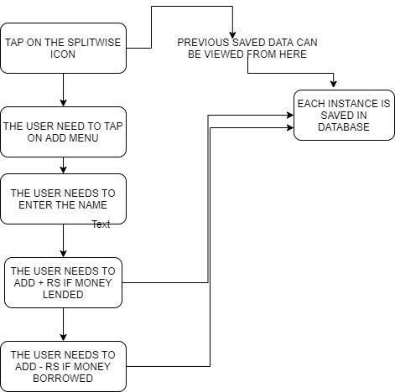

Fig 3: Splitbill Architecture

### 5.4. Stock Market

This feature helps the user to view the latest stock market using a API which is viewed inside a web view.

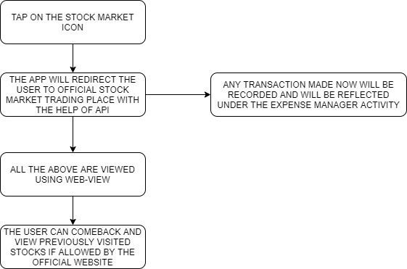

Fig 4: Stock Market Architecture

The user can visit the official trading place and make transactions. Payment can be done with the UPI feature present within the app.

### 5.5. Offers/Coupons

This feature provides the user with the latest ongoing offers in popular categories that are available on trusted ecommerce websites. The user can fetch the coupon code and shop within the app using Web view feature.

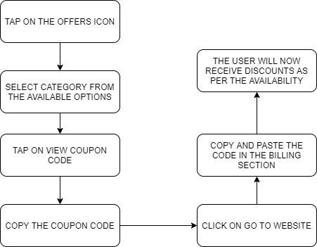

Fig 5: Offer / Coupons Architecture

### 5.6. Finance News

This features provides the user with authenticated finance news. The news is fetch from various financial news websites using the help of an trusted API.

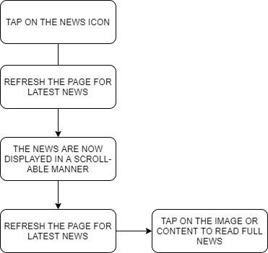

Fig 6: Finance News Architecture

*5.7. Upi Payment*

This feature is used for payment purposes. The UPI payment is designed and developed by the government of India.

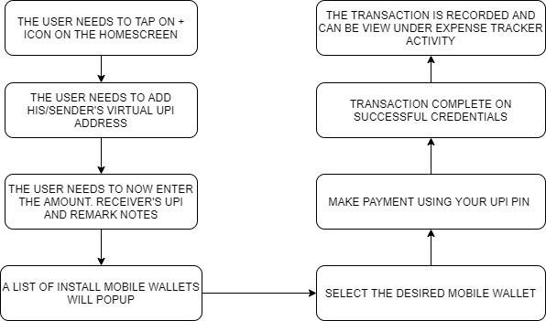

Fig 7: UPI Payment Architecture

Integrated into the app this app feature is a gateway for mobile wallets like Google pay, Phonepe, Paytm, amazon pay and others. The user needs to be a registered UPI user with UPI PIN set in any of the mobile wallets.

**Pseudocode: Manifest**

Expense Tracker

–

Sms Reading

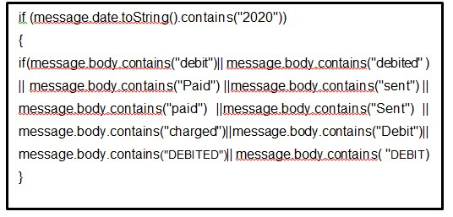

<

?xml version="1.0" encoding="utf

-

8

"?><manifest

xmlns:android=http://schemas.android.com/apk/res/a

ndroid

package="tech.risinglight.financebuddy">

<

uses-permission

android:name="android.permission.READ_SMS"

/><uses-permission

android:name="android.permission.WRITE_SMS" />

<

uses-permission

android:name="android.permission.Write_External_S

torage"

/>

## 6. Results And Discussion

We chose to build this idea on android platform because of its highest market share in mobile operating system. Please refer below figure:

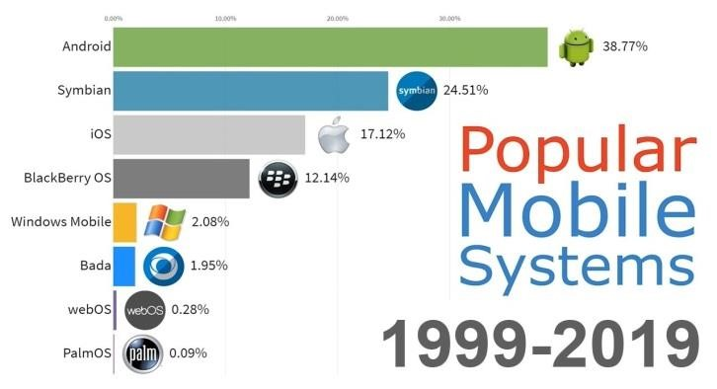

Fig 8: Most Used Mobile Operating System Graph

In the first phase of installing the application we need to give SMS read permission to the app since the whole idea of the app revolves around the transactions made online for which you get a message after any transaction done.The blueprint was finally put into custom designed the following output was obtained. Please refer to FIG 4.1 (Blueprint To Final User Interface) .The**+** icon represents UPI card add button where you can add your UPI ID to make payments within the app. All you need to do is type in your mobile number registered with your bank and followed by your UPI provided and tap on ADD UPI. This feature is used for payment purposes. The UPI payment is designed and developed by the government of India. Integrated into the app this app is a gateway for mobile wallets like Google Pay, Phonepe, Paytm, Amazon Pay and others.

The user needs to be a registered UPI user with UPI PIN set in any of the mobile wallets. Below the Select an option there are 5 more icon which represents 5 more features of this app (Left to Right).

* **1st Icon –Investment consultant –** It asks for the user’s budget for investment. Accordingly the app suggests the best suitable option available using the help of the algorithm designed.
* **2nd Icon – Stock Market –** This feature helps the user to view the latest stock market using an API from Money Control website.
* **3rd Icon – Financial News –** This features provides the user with authenticated finance news. The news is fetch from various financial news websites using the help of an trusted API.
* **4th Icon – Split Bills –** This feature is used to split bills among friends and groups i.e. any record of money lent or borrowed is stored here.
* **5th Icon – Offers Zone –** This feature provides the user with the latest ongoing offers in popular categories that are available on trusted ecommerce websites.

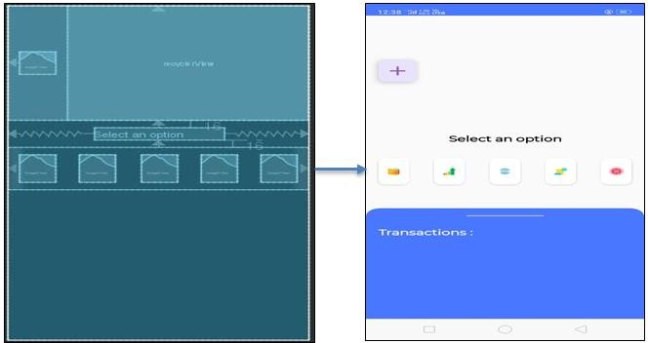

Fig 9 : Blueprint And Final Application

6.1. Future Enhancement

We commit to include the accompanying highlights into our cost chief application, demonstrating patterns, afterward we are going to include patterns. This is often the graphical portrayal of the final client costs per certain period, that might be month to month, quarterly, half-yearly and yearly too. Evaluating costs the opposite part interesting piece of our cost supervisor application is to measure costs that client may spend in present or one month from now. This can assist the client with adjusting his costs appropriately so he/she can abstain from bobbing up short on cash, gathering client information .The assortment of knowledge of costs and pay of client from databases is easy undertaking since each record of client action is put away straightforwardly in database server maintained by us. Yet, to create our application safe and to stay up secrecy of client information we attempt vital strides to counter this issue. We are going to request client authorizations to utilize client information for examination reason and can guarantee classification of every datum identified with information. the knowledge tests are gathered from client without uncovering any of client personality. Applying information mining strategies. the knowledge gathered from client is used to develop certain client examples, bunching and relationship of the prices.

The extraction of intriguing examples that's non-insignificant, certain, already obscure and possibly helpful examples or information from immense measure of knowledge. We’d apply suitable calculations of some popular information mining methods accessible today. In any case, this could require assistance from an information mining master. Use designs in advertise examination.

The knowledge gathered from client and also the examples advanced after applying information mining procedures as explained within the above piece of this report are utilized for advertise examination. The specialists within the market can utilize these samples of client consumptions enthusiastic about age, sexual orientation, and spot of client. This can help advertise strategist to style in like manner with the goal that it balance out the interest supply within the market profiting all the partners.

## 7. Conclusion

We have developed a mobile application that Keeps track of all of your daily transactions, keeps track of your money lent or borrowed ,suggests you with the most effective investment options, offers your discounts in popular categories , view exchange and to read latest authenticated financial news. This paper’s main aim to eliminate the use of sticky notes, spreadsheets and handling of large chunks of data is successful, the new experience is hassle-free and very handy. Now, with our application user can manage his expenses more effectively. This application can also help digital marketing agencies in rolling out their advertising campaigns more effectively.